<https://github.com/iqbal966>

Open xampp

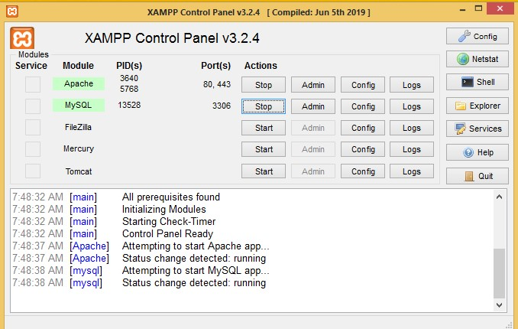

Run terminal to start local host

C:\xampp\htdocs\inventory>**php -S localhost:8888 -t public public/index.php**

PHP 7.3.9 Development Server started at Tue Oct 29 14:01:49 2019

Listening on http://localhost:8888

Document root is C:\xampp\htdocs\inventory\public Press Ctrl-C to quit.

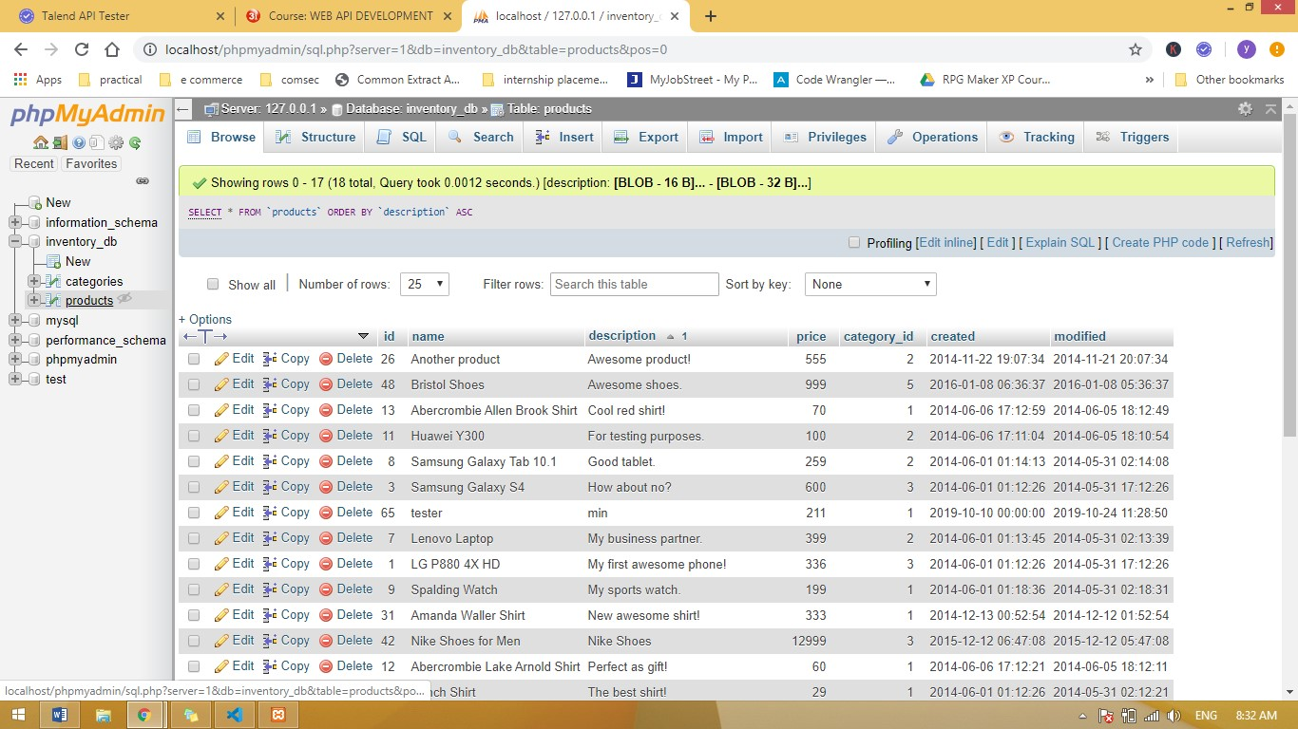

POST METHOD INTERFACE



http://localhost:8888/products

**Create new ID API TEST**

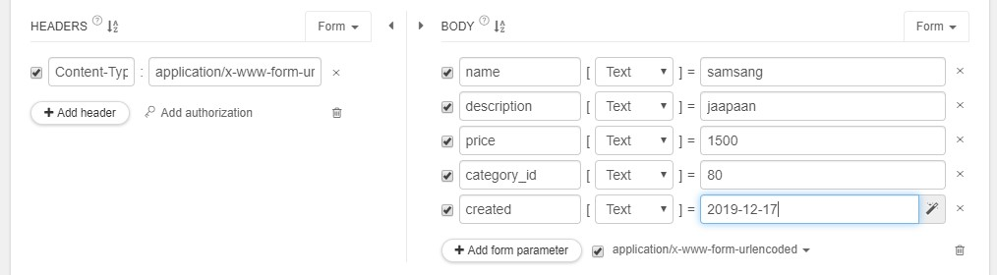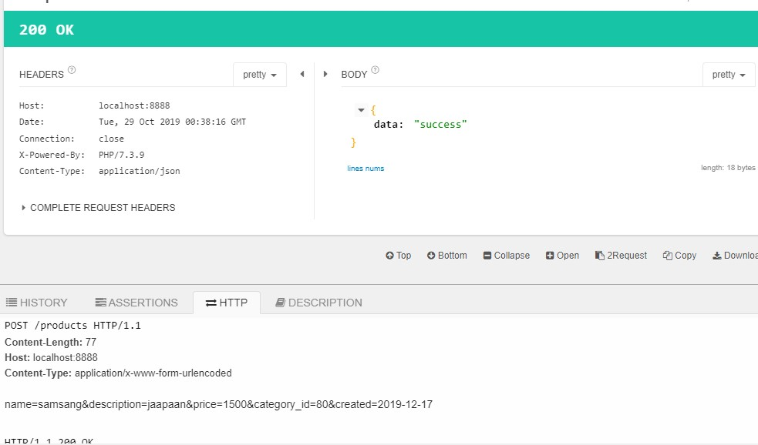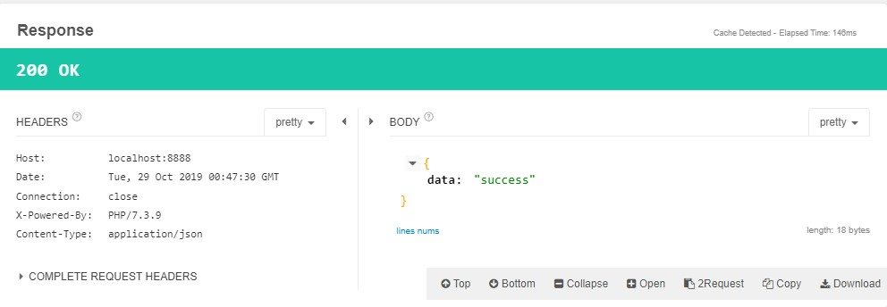

UPDATE METHOD INTERFACE

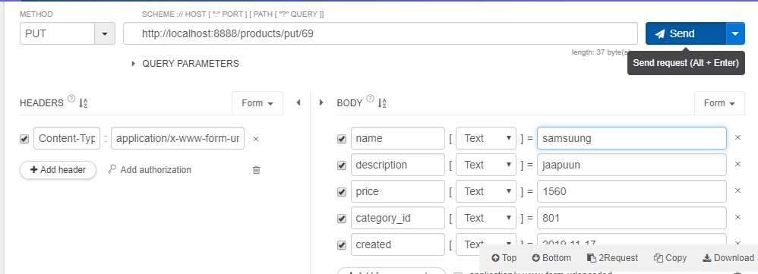

http://localhost:8888/products

/put/69

GITHUB ADDRESS

Delete method interface

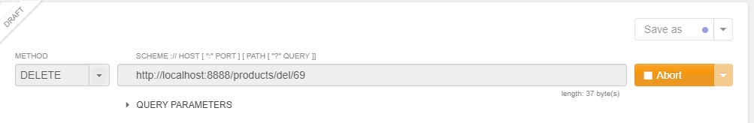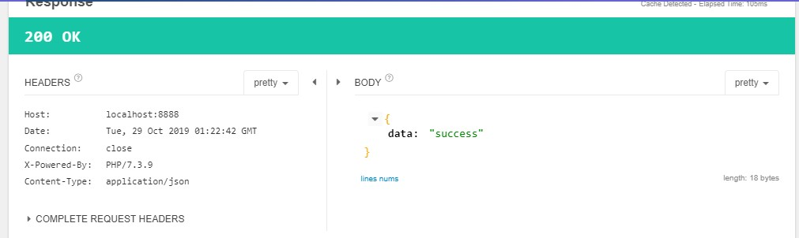

http://loc alhost:8888del/69

<https://github.com/iqbal966/Inventory-Assignment-1>